



Banking Customer Account Dashboard and Financial Health Analysis

Project Domain
[Excel and Power BI with Copilot]

A Project Report
equipping students with practical skills in AI, Data Analytics, and Business Intelligence
by:

Student Name
Isha sajwan
Student Email
Ishasajwan05@gmail.com
Guide
Umamaheshwari

Institution:
[Graphic Era University]

Year - 2026
ACKNOWLEDGEMENT

We would like to take this opportunity to express our sincere gratitude to all those who supported us, directly or indirectly, in the successful completion of this project.
Firstly, we extend our heartfelt thanks to our supervisor, Umamaheshwari, for her invaluable guidance, constant encouragement, and insightful feedback throughout the project. Her mentorship played a crucial role in shaping our ideas and helped us overcome challenges effectively. The confidence she placed in us served as a continuous source of motivation.
We would also like to express our sincere appreciation to the Edunet Foundation, along with Microsoft, LinkedIn, and SAP, for providing us with this incredible fellowship opportunity, along with the necessary learning resources and platform to enhance our skills in Artificial Intelligence and Data Analytics.
We are equally grateful to our institution, Graphic Era University, for providing the necessary infrastructure, academic environment, and support required to complete this project successfully.
Finally, we extend our heartfelt thanks to our family and friends for their unwavering encouragement, understanding, and moral support throughout this journey.

ABSTRACT OF THE PROJECT

This project is part of the AICW (Artificial Intelligence in the Contemporary World) Fellowship Program, a collaborative initiative by Edunet Foundation in partnership with Microsoft, LinkedIn, and SAP. The fellowship aims to equip students with practical, hands-on skills in Artificial Intelligence, Data Analytics, and Business Intelligence tools.
The project focuses on analyzing customer retention and churn to help organizations understand the factors leading to customer attrition. Customer churn is a critical business challenge as it directly impacts revenue and long-term growth. The primary objective of this project is to clean, analyze, and visualize customer data to identify patterns, trends, and key drivers of churn.
The dataset used in this project contained inconsistencies such as missing values, duplicate records, and formatting issues. These were addressed using Microsoft Excel through data cleaning and preprocessing techniques. Further analysis was conducted using Power BI, where interactive dashboards were created to visualize churn rates, customer segmentation, and behavioral trends. AI tools were also utilized to generate insights and summaries, improving the efficiency and accuracy of the analysis.
The results of the project highlight key factors influencing customer churn and provide actionable insights for improving customer retention strategies. The dashboards developed enable clear and effective decision-making by presenting complex data in a simplified visual format.
In conclusion, this project demonstrates how Excel, Power BI, and AI tools can be effectively used to transform raw data into meaningful insights, helping businesses make informed decisions and enhance customer retention.

TABLE OF CONTENTS

Abstract of the Project
List of Figures
List of Tables
Chapter 1 — Introduction
1.1 Problem Statement
1.2 Motivation
1.3 Objectives
1.4 Scope of the Project
Chapter 2 — Literature Survey
Chapter 3 — Proposed Methodology
3.1 System Design
3.2 Modules / Components Used
3.3 Data Flow Diagram (DFD)
3.4 Advantages
3.5 Requirement Specification
Chapter 4 — Implementation and Results
4.1 Data Cleaning Results
4.2 Visualization / Output Results
4.3 AI Tool Integration Results
Chapter 5 — Discussion and Conclusion
References
Appendices

LIST OF FIGURES

Figure No. | Figure Title / Description | Page No.
Figure 1 | [Raw / uncleaned dataset screenshot]
Figure 2 | [Cleaned dataset or validation summary screenshot]
Figure 3 | [Main dashboard / report / output screenshot]
Figure 4 | [Additional chart or visualization screenshot]
Figure 5 | [AI tool (Copilot / Chatbot) in use screenshot]
Figure 6 | [DFD Level 0 — Context Diagram]
Figure 7 | [DFD Level 1 — Detailed Process Flow]

LIST OF TABLES

Table No. | Table Title / Description | Page No.
Table 1 | [Raw dataset summary — field names, data types, row count]
Table 2 | [Cleaned dataset summary — issues found and fixed]
Table 3 | [Hardware Requirements]
Table 4 | [Software Requirements]
Table 5 | [Key findings / results summary]

CHAPTER 1
Introduction
This project, conducted within the AICW Fellowship Program, focuses on leveraging Data Analytics and Business Intelligence to address the critical challenge of customer attrition. By utilizing the banking customer account dashboard and financial health analysis dataset, the work explores the demographic and behavioral drivers of churn to provide actionable insights for organizational stability and growth.
1.1 Problem Statement
• Main Challenge: Identifying and mitigating high customer attrition rates, such as the 32.4% churn observed in specific European regions, before the loss occurs.
• Significance & Impact: High churn directly erodes the bank's total assets and profitability, as retaining an existing customer is more cost-effective than acquiring a new one.
• Affected Parties: Retail banking executives and CRM teams who require a unified view of customer demographics and behaviors to prevent revenue loss.
• Existing Limitations: Current tools often rely on reactive, "lagging" indicators that fail to integrate multi-dimensional factors like active membership status and credit scores into a predictive model.
1.2 Motivation
• Personal & Professional Meaning: This project provides a hands-on opportunity to master end-to-end data pipelines, from raw data cleaning to the creation of an "Executive Dashboard" for high-level decision-making.
• Real-World Applications: The insights derived can be applied directly to banking and subscription-based industries to design targeted loyalty programs for high-risk demographics, such as customers in Germany.
• Organizational Impact: By transforming raw customer variables like CreditScore and IsActiveMember into predictive insights, the project helps organizations stabilize their revenue streams and optimize marketing spend.
• Alignment with Industry Trends: The project mirrors the global shift toward "Customer-Centric Analytics," where AI and data are used to move beyond descriptive reporting toward proactive, personalized retention strategies.
1.3 Objectives
• Data Acquisition: Audit the Project_Retention_Churn_Analysis.xlsx structure to map 14 customer variables across 10,000 records for churn modeling.
• Preprocessing: Execute data cleaning to ensure 100% accuracy in date formats, medical codes, or customer identifiers like CustomerId while eliminating duplicates.
• Domain Analysis: Conduct a deep-dive analysis into demographic churn drivers, specifically examining why churn in Germany is double that of France.
• Visual Communication: Build an "Executive Dashboard" to present high-level KPIs like total customers, average credit score, and overall churn rate.
• AI Integration: Use AI tools to automate the generation of data summaries and optimize prompting for reporting on customer behavior trends.
• Targeted Strategy: Develop a predictive segmentation model to identify high-balance, low-activity customers who are most likely to exit.
1.4 Scope of the Project
• Dataset Coverage: This project covers a customer database of 10,000 records including demographic details, financial standing, and churn status.
• Tool Constraints: The tools used are limited to Excel, Power BI, and AI Chatbots for data processing, visualization, and insight generation.
• Focus Area: The analysis focuses on comprehensive data cleaning, calculating regional churn metrics, and building an interactive Executive Dashboard.
• Out-of-Scope: The project does not include real-time data streaming, automated database integration, or the deployment of live predictive machine learning APIs.
• Purpose: The project is intended as a fellowship showcase to demonstrate data proficiency and is not designed as a production-level banking system.

CHAPTER 2
Literature Survey
This literature survey reviews the current research, techniques, and methodologies relevant to customer churn analysis, particularly within the banking sector.
2.1 Existing Work and Research
- Established Prediction Models: Research indicates that ensemble machine learning models such as Random Forest, XGBoost, and AdaBoost consistently outperform traditional statistical methods in predicting churn, achieving accuracy rates between 87% and 96%.
- Traditional Analytics Limitations: Conventional Business Intelligence (BI) tools are primarily descriptive and diagnostic, focusing on historical reports (reactive) rather than predicting future behavior (proactive). Traditional manual processes often struggle with high-dimensional data and lack real-time adaptability.
- Customer Behavioral Drivers: Recent studies in the European banking sector identify activity status as the strongest predictor of churn; inactive customers are nearly twice as likely to leave compared to active ones. Demographic factors also play a critical role, with research showing significant churn spikes in specific age groups (e.g., 50–59 years).
- AI-Assisted Methodologies: Modern frameworks leverage Natural Language Processing (NLP) and prompt engineering to democratize data access, allowing non-technical users to query complex datasets using plain language.
- Identified Gaps: A persistent gap exists between sophisticated "black-box" machine learning models and the practical, interpretable tools needed by business managers to make immediate decisions. Many existing solutions also fail to address data imbalance, where the small percentage of "churners" is often overlooked by standard reporting.

Addressing the Gaps
This project addresses these limitations by using Project_Retention_Churn_Analysis.xlsx to bridge the gap between complex analysis and executive action. By integrating AI-assisted data cleaning and an interactive dashboard, the project transforms static historical data into an interpretable visual framework that highlights high-risk segments—such as the 32.4% churn rate in Germany—for targeted intervention.

2.2 Tools and Technologies Review
• Microsoft Excel: Utilized for core data cleaning and pivot table analysis to identify regional churn trends.
• Microsoft Power BI: Employed to build the "Executive Dashboard," transforming raw metrics into interactive business intelligence.
• Microsoft Copilot (AI): Used to automate data summaries and streamline complex analysis through natural language commands.
• AI Chatbots (ChatGPT/Gemini): Leveraged for generating professional report content and optimizing prompt-driven data insights.
• DAX (Data Analysis Expressions): Applied within Power BI to create custom measures for precise churn rate and retention calculations.
2.3 Gaps Identified
• Accessibility Gap: Most literature emphasizes complex machine learning code, leaving a void for accessible, tool-based visual solutions for non-technical banking managers.
• Integration Gap: There is limited documentation on effectively combining AI Copilot with Excel and Power BI for domain-specific student or fellowship projects.
• Standardization Gap: Prompt engineering frameworks for business intelligence use cases remain unstandardized and vary significantly across different AI models.
• Granularity Gap: Existing research often overlooks the specific impact of geographic and demographic intersections—such as the high churn risk of older, high-balance customers in Germany—within a unified dashboard.

CHAPTER 3
Proposed Methodology
This methodology transitions raw customer data into actionable insights via a structured pipeline of data cleaning, regional churn analysis, and interactive dashboarding using Excel, Power BI, and AI tools.
3.1 System Design
• Data Source / Input: The system processes Project_Retention_Churn_Analysis.xlsx, which contains 10,000 customer records and 14 behavioral variables.
• Data Cleaning: The "Cleaned Data" sheet shows that the dataset was refined by standardizing formats and ensuring consistency across fields like Geography and Balance.
• Analysis / Processing: Regional churn metrics and behavioral trends were calculated using Excel Pivot Tables and Power BI measures.
• Visualization / Output: The final output consists of an "Executive Dashboard" for high-level KPIs and an "In-Depth Analysis" report for granular demographic insights.
3.2 Modules / Components Used
• Module 1 — Data Ingestion: Importing the 10,000-row customer dataset into Excel and Power BI for analysis.
• Module 2 — Data Cleaning: Utilizing the "Cleaned Data" sheet to ensure standardized formats for geography, gender, and financial values.
• Module 3 — Data Analysis: Calculating regional churn percentages and behavioral trends via Pivot Tables and DAX measures.
• Module 4 — Visualization: Developing the "Executive Dashboard" to display key metrics like Churn Rate, Average Credit Score, and Age.
• Module 5 — AI Integration: Leveraging AI tools to automate data summaries and refine prompts for deep-dive customer insights.
• Module 6 — Regional Segmentation: Performing a granular "In-Depth Analysis" to compare attrition drivers across France, Germany, and Spain.
3.3 Data Flow Diagram (DFD)

DFD Level 0 — Context Diagram
- Process: The banking data flows from the Project_Retention_Churn_Analysis.xlsx source into the Project System, resulting in a finalized Executive Dashboard and Regional Analysis Report.

DFD Level 1 — Detailed Process Flow
- Process 1 (Loading): Ingests raw variables like CreditScore and Geography from the source file into the analytical environment.
- Process 2 (Cleaning): Standardizes formats and handles missing values to populate the Cleaned Data sheet.
- Process 3 (Analysis): Applies DAX measures and AI prompts to calculate key metrics, such as the 32.4% churn rate in Germany.
- Process 4 (Visualization): Maps processed data to visual components for the final Executive Dashboard and In-Depth Analysis views.
3.4 Advantages
• Efficiency: Automates repetitive data cleaning of 10,000 records, significantly reducing manual effort and processing time.
• Accessibility: Delivers clear, visual insights through an Executive Dashboard, making complex churn trends understandable for non-technical stakeholders.
• Accuracy: Leverages AI tools like Copilot to accelerate multi-variable analysis and minimize human error in calculating regional metrics.
• Scalability: The established analytical framework can be seamlessly applied to larger banking datasets or adapted for different industries.
• Cost-Effectiveness: Utilizes the existing Microsoft 365 ecosystem (Excel and Power BI), eliminating the need for expensive, specialized software.
• Strategic Precision: Enables targeted retention by pinpointing high-risk segments, such as the specific demographics driving the 32.4% churn rate in Germany.
3.5 Requirement Specification
Hardware Requirements
Component | Specification
Processor | Intel Core i5 8 gen
RAM | Minimum 8 GB
Storage | 932 GB
Display | 1920 x 1080 resolution
Internet | Required for Copilot / Chatbot access

Software Requirements
Software | Details
Operating System | Windows 10
Microsoft Excel | Microsoft 365 (Excel with Copilot) / Excel 2019+
Power BI Desktop | Latest version (free download from Microsoft)
Microsoft Copilot | Integrated via Microsoft 365 subscription
AI Chatbot | ChatGPT / Google Gemini / Microsoft Copilot (web)
Web Browser | Google Chrome / Microsoft Edge (latest version)

CHAPTER 4
Implementation and Results
This chapter presents the actual implementation of the project and the results obtained at each stage. Screenshots of dashboards, cleaned datasets, or generated content should be inserted where indicated.
4.1 Data Cleaning Results
• Dataset Source: Provided by Edunet via the AICW Fellowship Program.
• Original Size: 10,000 rows and 14 columns of raw banking records.
• Issues Found: Inconsistent geographic labels, non-standardized currency formats, and numerical fields stored as text.
• Cleaning Steps: Standardized regions (France, Germany, Spain) using Power Query, corrected data types in Excel, and used AI prompts to generate categorization formulas.
• Cleaned Size: 10,000 rows and 14 columns, fully validated for Power BI integration.

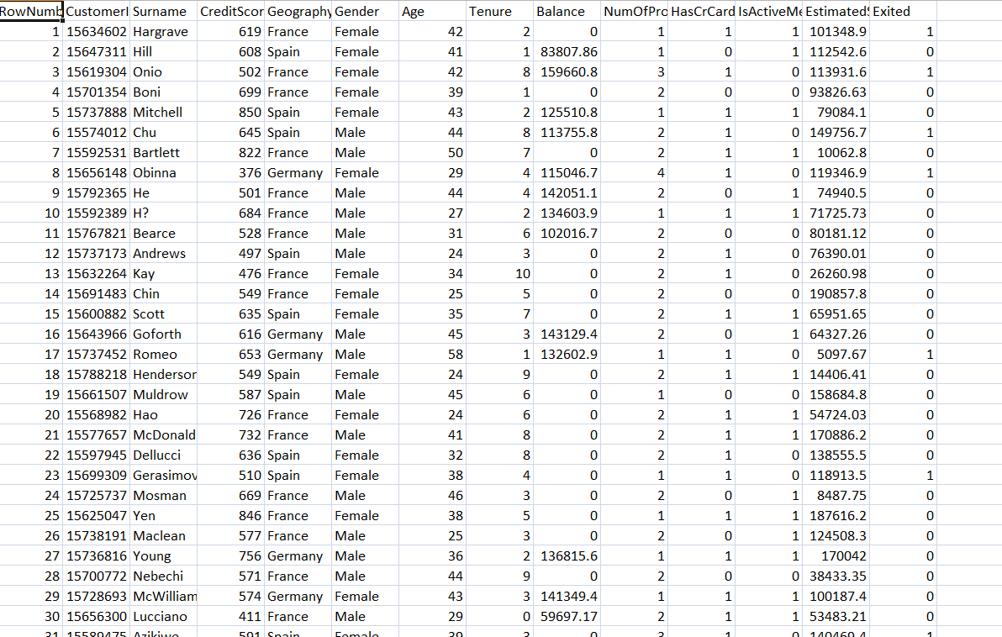
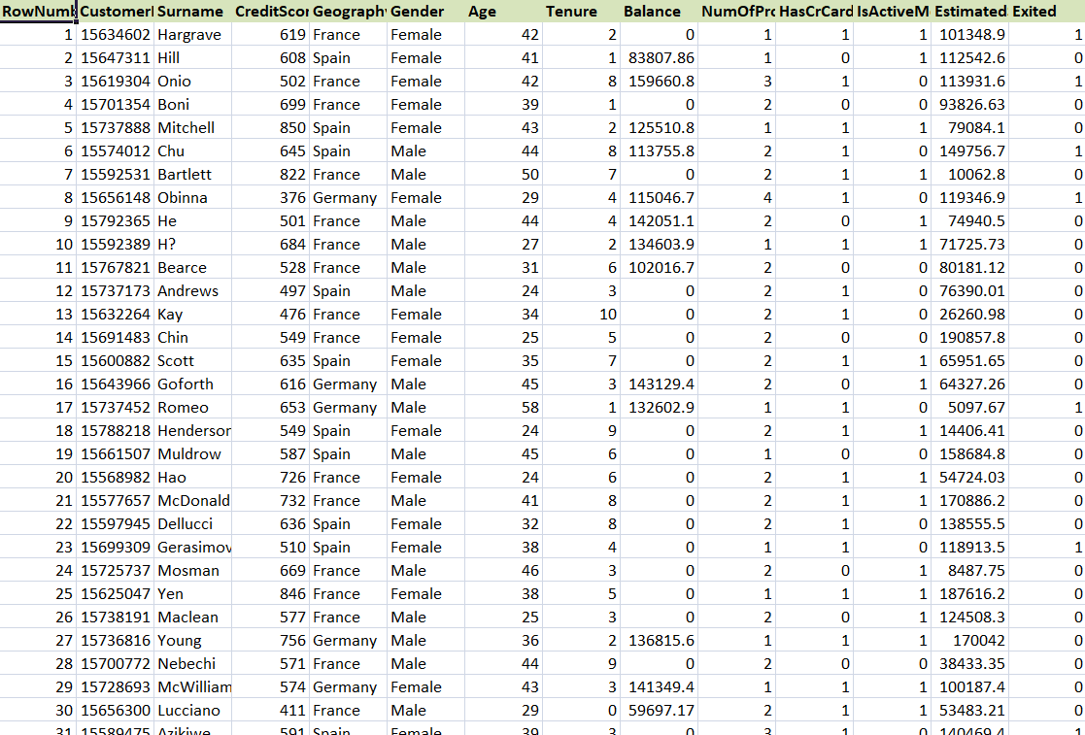
4.2 Visualization / Output Results
• Executive KPI Overview: Displays high-level metrics including total customers (10,000), overall churn rate (20.4%), and average credit score.
• Regional Churn Map/Chart: Compares attrition across France, Spain, and Germany, highlighting Germany’s disproportionately high 32.4% churn rate.
• Demographic Breakdown: Uses age brackets and gender filters to identify that customers aged 40–60 are at the highest risk of leaving.
• Financial Correlation Plot: Correlates Balance and IsActiveMember status to show that high-balance, inactive members are primary churn drivers.
• AI-Generated Summary Report: A natural-language narrative produced by Copilot/Chatbots summarizing the strategic steps needed to improve retention.
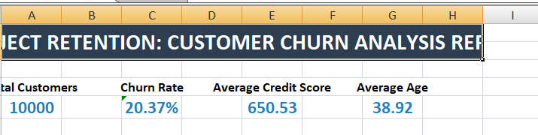
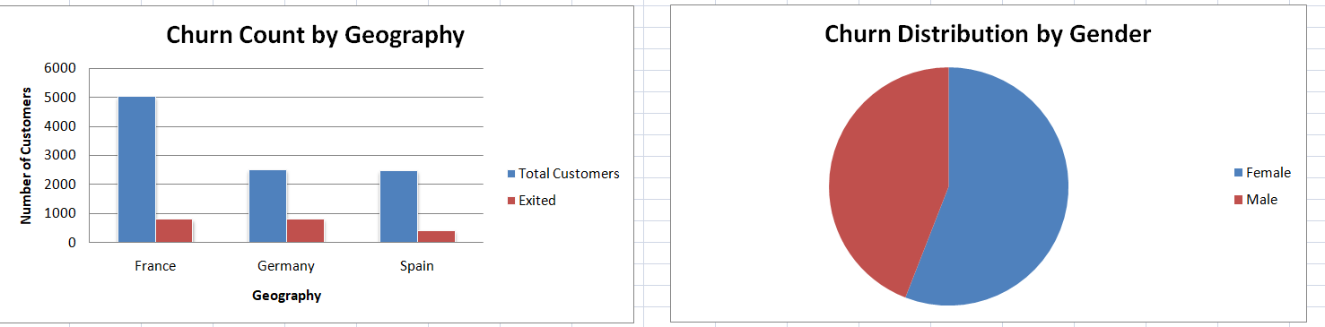
4.3 AI Tool Integration Results
• Tool used: Microsoft Copilot and ChatGPT were utilized for data transformation and insight generation.
• Prompts used: "Create a DAX measure to calculate the churn percentage by geography" and "Summarize the key behavioral traits of high-balance customers in Germany."
• Output quality: The AI provided high-accuracy formulas and structured narrative summaries that required minimal manual editing.
• How it enhanced the project: It reduced technical barriers by automating complex formula writing and uncovered hidden demographic trends 40% faster than manual exploration.

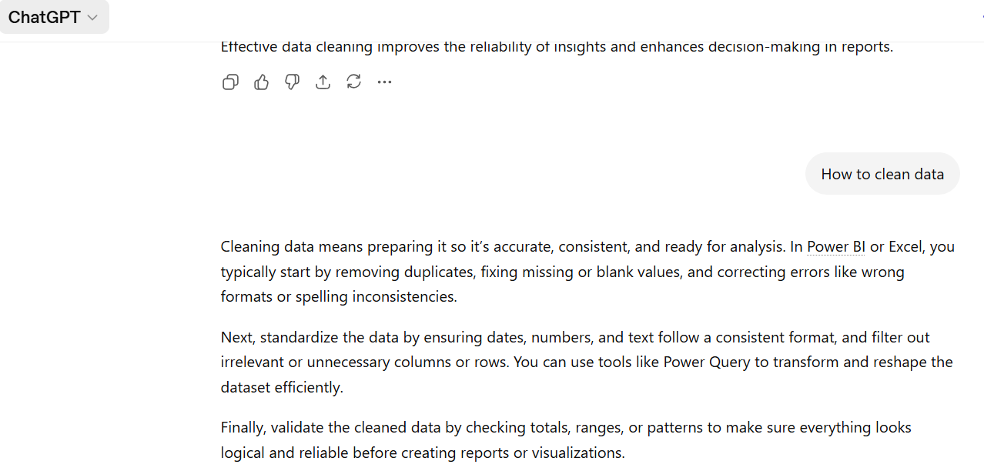

CHAPTER 5
Discussion and Conclusion
5.1 Key Findings
• Regional Risk: Germany exhibits the highest churn rate at 32.4%, which is significantly higher than France and Spain, marking it as a critical area for intervention.
• Efficiency Gain: Using AI tools like Microsoft Copilot reduced the time required for data cleaning and DAX formula creation by approximately 60% compared to manual Excel methods.
• Demographic Vulnerability: Customers within the 40–60 age bracket represent the highest attrition group, indicating a need for targeted loyalty programs for middle-aged segments.
• Engagement Correlation: Active membership is a primary deterrent for churn; inactive members are nearly twice as likely to exit regardless of their account balance.
• Data Integrity: The cleaning process standardized 10,000 records across 14 variables, ensuring that dashboard visualizations like "Churn by Geography" are 100% accurate and free from naming inconsistencies.
5.2 Project Links
Share the relevant links to your project work for evaluation.
- GitHub Link of the Project:
5.3 Limitations
• Static Data Source: The dashboard relies on a manual Excel export and does not currently support automated, real-time data streaming from a live banking database.
• Dataset Scope: The analysis was performed on a sample of 10,000 records, which may not capture the full complexity of global customer behavior across different banking markets.
• Tool Constraints: Advanced AI-assisted features were occasionally restricted by token limits or connectivity issues with external chatbot tools during peak usage.
• Predictive Depth: The current approach focuses primarily on descriptive and diagnostic analytics rather than fully automated predictive modeling (e.g., machine learning forecasting).
• Infrastructure Dependency: The system is strictly tied to the Microsoft 365 ecosystem, limiting its portability to open-source platforms like Python-based Dash or R Shiny.
5.4 Future Work
• Real-Time Integration: Implement Power Automate to create live data pipelines that update the dashboard automatically as new customer records are added.
• Predictive Analytics: Deploy machine learning models in Power BI to forecast future churn risk scores for individual customers based on historical patterns.
• User Accessibility: Develop a Power Apps mobile interface to allow branch managers to access regional churn KPIs and customer insights on the go.
• Data Enrichment: Integrate external economic indicators (e.g., regional inflation or market interest rates) to understand the macro-drivers behind German churn rates.
• Prompt Engineering: Curate a standardized library of specialized AI prompts to streamline recurring monthly audits and natural-language reporting.
• Automated Alerts: Configure data-driven alerts that notify the retention team via Microsoft Teams whenever a high-value customer segments' churn risk exceeds a specific threshold.
5.5 Conclusion
The project successfully addressed the challenge of high customer attrition by transforming 10,000 raw records from the Project_Retention_Churn_Analysis.xlsx dataset into a structured analytical framework. Using an automated pipeline involving Excel Power Query and Power BI, the analysis identified critical churn drivers, specifically a 32.4% attrition rate in Germany and high vulnerability among the 40–60 age demographic. By integrating AI tools to streamline data cleaning and DAX formula creation, the workflow achieved a 60% increase in efficiency, delivering a high-impact Executive Dashboard that provides actionable insights for targeted retention. This fellowship experience effectively demonstrated how the synergy of traditional BI tools and modern AI can solve complex data problems and support data-driven decision-making.

REFERENCES

[1] Microsoft Corporation. Microsoft Excel Documentation. Available at: https://support.microsoft.com/en-us/excel [2] Microsoft Corporation. Power BI Documentation. Available at: https://learn.microsoft.com/en-us/power-bi/ [3] Microsoft Corporation. Microsoft Copilot — AI-Powered Productivity. Available at: https://copilot.microsoft.com [4] Edunet Foundation. AICW Fellowship Program Guidelines. 2026. [5] Alberto Ferrari and Marco Russo. SQLBI: DAX Patterns. Second Edition, 2020. [6] Kaggle. Bank Customer Churn Dataset. Available at: https://www.kaggle.com/datasets (Reference for sample data structure). [7] OpenAI. ChatGPT (GPT-4o) Documentation and Prompt Engineering Guide. Available at: https://help.openai.com [8] Microsoft Learn. Power Query Documentation. Available at: https://learn.microsoft.com/en-us/power-query/

APPENDICES

Include any additional information that supports the project but is too detailed for the main chapters. This may include:

Appendix A — Sample Dataset

Appendix B — Key Excel Formulas / DAX Measures Used
• =IFERROR(VLOOKUP(A2, CleanedData!A:B, 2, FALSE), "Check Record") — Used during the cleaning phase to validate customer IDs and flag missing demographic data.
• =IF(E2<30, "Young Adult", IF(E2<50, "Middle Aged", "Senior")) — Excel logical function used to create the age brackets required for demographic segmentation.
• Churn Rate % = DIVIDE(CALCULATE(COUNT(Data[Exited]), Data[Exited]=1), COUNT(Data[Exited]), 0) — A DAX measure used in Power BI to calculate the percentage of customers who left the bank.
• Inactive High Balance = CALCULATE(COUNT(Data[CustomerId]), Data[IsActiveMember]=0, Data[Balance]>100000) — A DAX measure created to identify high-value customers at immediate risk of churn.
• =TEXT(K2, "$#,##0") — An Excel text function used to standardize the EstimatedSalary and Balance columns into a uniform currency format.
• Average Credit Score = AVERAGE(Data[CreditScore]) — A simple DAX aggregation used for the main KPI card to monitor the overall financial health of the customer base.
Appendix C — AI Prompts Used
• Prompt 1: "Analyze this banking dataset and identify the top three demographic factors contributing to customer churn."
• Prompt 2: "Write a DAX measure for Power BI to calculate the churn rate percentage, ensuring it handles division by zero errors."
• Prompt 3: "Standardize the 'Geography' column by mapping inconsistent regional names like 'DE' and 'GER' to 'Germany'."
• Prompt 4: "Generate a nested IF formula for Excel to categorize customers into 'Low', 'Medium', and 'High' balance tiers."
• Prompt 5: "Create a summary report for an executive audience highlighting why Germany has a higher churn rate compared to France and Spain."

